**Networking between local machine (windows) and VM (Linux):**

* There are two ways:

Method-1: Samba configuration

Method-2: Add IP and hostname manually

**Method-2: Add IP and hostname manually:**

* Select NAT as Network connection in VMware/ Virtual Box
* Set IP address of local machine.

Ctrl+R > ncpa.cpl > VMware Network Adapter VMnet8 > right click > Internet Protocol Version 4 (TCP/IPv4) > select > Properties > assign IP address and Subnet mask

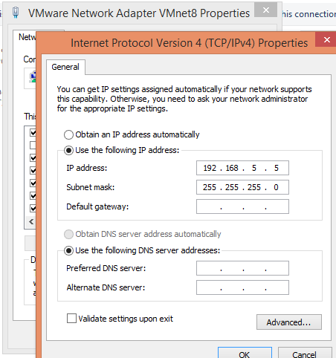

* Note down name of local machine.

Start > Computer > right click > Properties > Computer name



* Add IP address and hostname of local machine to /etc/hosts file of VM.

